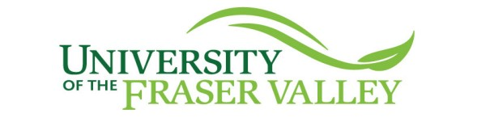

Project Milestone Report #1:

Gamified Ethical Case Study Report

*Due: October 30, 2025 11:59 PM*

CIS 485

Fall 2025

Instructor: Parsa Rajabi

## Group Members:

**Project Manager:** Samee Maqbool

**Lead Writer:** Riley Emery

**Documentation Lead:** Jannat Sandhu

**Quality Assurance:** Mohit Toor

**Graphics/Design:** Bismanpreet Kaur

# Introduction

Our team hosted our project kick-off meeting on the 5th of October for us to introduce ourselves to each other and get the ball rolling on this project. This meeting was to make sure everyone was on the same page on what it was we had to do and that everything was okay with each other. Prior to this, we all individually looked over the project details on our course page just as prep for this meeting. In this quick meeting, we went over which case study to work on, what tools to use, and we cleared up any confusion so that we all remain on the same page. We decided to go with the “Abusive Workplace Behavior” case study as it was the most familiar, and we came up with ideas for a storyline very quickly. The tools we wanted to use were originally Figma due to its wide usage and transferability into the job market however, we then realized this was only for the flowchart, and we used [draw.io](http://draw.io) instead, as everyone was more collectively familiar with it. We met afterwards on the 13th of October to assign roles and due dates, and ensure that we are continuously uploading drafts onto GitHub and revising as a group.

# Case Study Chosen

Our group decided to Choose The 'Abusive Workplace Behaviour' case study because it reveals a very powerful case that anyone can encounter in a stressful work environment. This case sheds light on some key points that can convert the work environment into a toxic one. Things like disrespectful behaviour towards other employees, misusing power, and being unable to perform the leadership role can make a work environment unhealthy.

We thought it was very important to educate ourselves on what can happen in a toxic workplace and what is the ethical way to approach it.

# Draft List of Ethical Delemmas

For Jean it would be:

1. Either fire max or ignore and keep max.
2. Protect the team or protect the project.

For Diane it would be:

1. Report the situation to HR or quit without saying anything.
2. Calling Max out in front of the whole team or talking to Jean first.

# Prototype Workflow:

(overview of paths and player choices; include 1–2 screenshots)

* Bring up topics in our meetings, refer to planning document tab
  + Bitlife as an example for learning how the game would work and its situations
  + Script work and idea flow
  + Github workflow
* Refer to the other document “Group Project Script” and describe how the game will work
* Specifically point out Ethical Dilemmas in our game and our outcomes.

### 

### 

### Bibliography

<https://www.acm.org/code-of-ethics/case-studies/abusive-workplace-behavior>

Recap:

* Cover Page: group info (names, roles, student IDs) and link to your deployed game - *this page does not count towards the page limit*
* Case Study Chosen and why you selected it
* Prototype Workflow: overview of paths and player choices; include 1–2 screenshots
* Draft List of Ethical Dilemmas your players will face
* Any external references in IEEE citation format (if applicable)